Printing to the screen

# **Description**

This tutorial is a guide for printing to the screen on Vex IQ robots

# **Instructions**

## **Log into laptop**

1. Take a laptop for your team from the Vex IQ laptop cart
2. Power on and log into the laptop
   1. Login: Student
   2. Password: obfuscate

## **Opening Robot C**

1. Look on the desktop for the Robot C icon. Select the “RobotC for Vex Robotics”  
   Do not open the “Graphical ROBOTC” program  
   1. 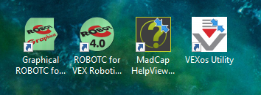
2. Open a new file and enter the following  
   1. 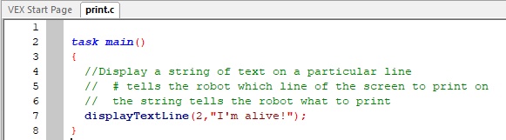
3. Select “Download Firmware”
   1. 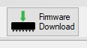
4. Compile the program
   1. Select “Compile”  
      
   2. If there are any errors, read the errors and correct them  
      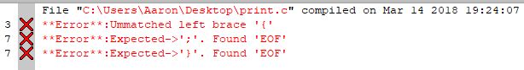

For example, the above errors tell us that there is an **unmatched left brace** – we’ve missed a ‘ } ’

1. Download the program to the robot
   1. Select “Download to Robot”  
      
   2. A prompt should come up. Press **start.**  
      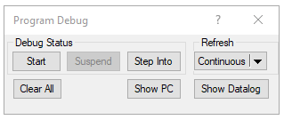
2. The Robot Brain should not display your message!  
     
   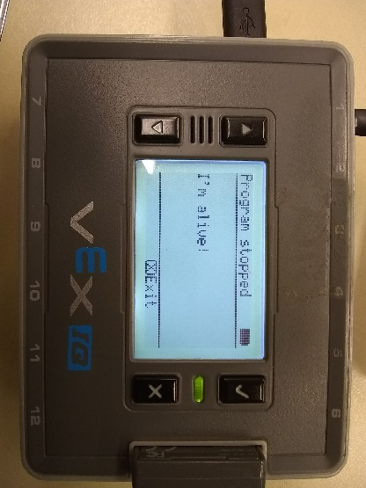
3. Change the command!
   1. Change the line number the statement is printed on
   2. Change the text that’s printed onto the display
   3. Compile and Download to Robot again. Then run to view your changed message!